Appendix C: IEEE 830 Template
Software Requirements Specification
For
Interactive Collaborative Logic Circuit Whiteboard

Version 4.0
Prepared by Kacper Ryba
TUL
20.04.2026

Table of Contents
«Table of Contents»
Revision History
Name | Date | Reason for Changes | Version
Kacper Ryba | 10.03.2026 | Initial version | 1.0
Kacper Ryba | 23.03.2026 | Added the UCD | 2.0
Kacper Ryba | 13.04.2026 | Added the UML | 3.0
Kacper Ryba | 20.04.2026 | Added the Sequence, Activity and State diagrams | 4.0

1. Introduction
1.1. Purpose
This document specifies the software requirements for the Interactive Collaborative Logic Circuit Whiteboard (ICLCW) v1.0. The system is a web-based application that allows multiple users to collaboratively design digital logic circuits in real time and automatically convert logical expressions into corresponding gate-level diagrams
1.2. Document Conventions
This document follows the IEEE 830 Software Requirements Specification standard. All requirements are written in a consistent and structured manner to ensure clarity, traceability, and verifiability.
Functional requirements are identified using the prefix FR-x, while non-functional requirements use the prefix NFR-x. Each requirement is uniquely numbered to support traceability throughout the development and testing process.
The keyword “shall” is used to indicate mandatory system behavior. Optional or future features may use the term “may”, although such requirements are not the primary focus of this document.
All requirements are written as atomic statements, meaning each requirement describes a single action or behavior. Complex behaviors are decomposed into multiple simpler requirements. Wherever applicable, requirements include quantifiable metrics (e.g., time constraints such as “within 500 ms”) to ensure they can be objectively tested.
1.3. Intended Audience and Reading Suggestions
The intended audience of the program are the students which will be the main group of users of the system to design and simulate circuits, as well as the instructors of the courses that have an aspect of the logic circuits design to evaluate student work and provide exercises. The other audience members are the developers and testers that will check their gate designs.
1.4. Product Scope
The system provides a shared digital workspace where users can create, edit, and simulate logic circuits collaboratively. It also supports automatic transformation of Boolean expressions into circuit diagrams, enabling faster learning and validation of digital logic concepts.
1.5. References
«List any other documents or Web addresses to which this document refers or was based on. These may include user interface style guides, contracts, standards, system requirements specifications, use case documents, or a vision and scope document. Provide enough information so that the reader could access a copy of each reference, including title, author, version number, date, and source or location. Include the assignment document in the references.»
2. Overall Description
2.1. Product Perspective
The system is a new standalone web application intended for educational use in digital logic courses. The following Use Case Diagram shows the project’s logic flow:
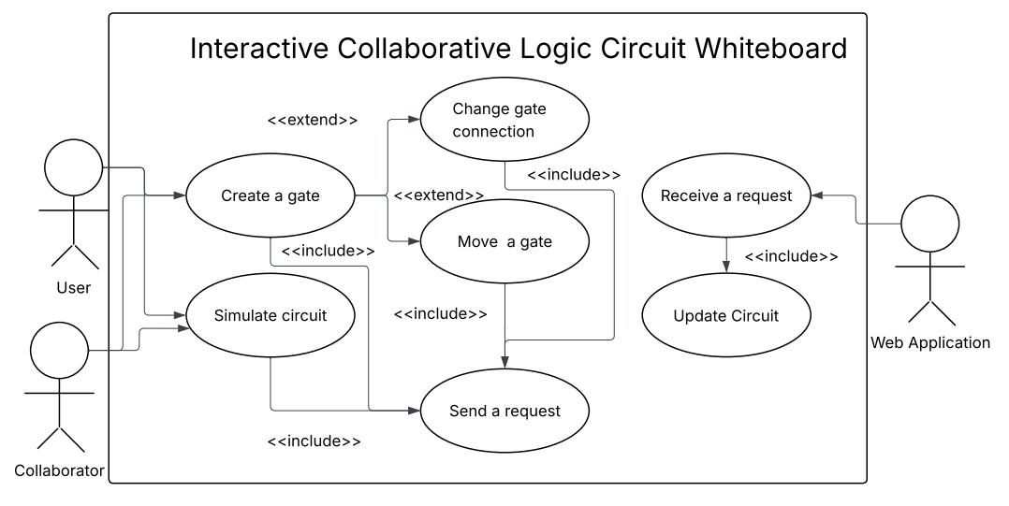
2.2. Product Features
The Interactive Collaborative Logic Circuit Whiteboard provides several core features that support both individual and collaborative work on digital logic design. The system enables real-time collaborative editing, allowing multiple users to interact with the same circuit simultaneously. Changes made by one user, such as adding or modifying components, are reflected to all other participants with minimal delay. Users can perform logic circuit creation by placing standard digital components such as AND, OR, and NOT gates on a shared canvas and connecting them using wires. This visual approach allows users to construct complex circuits intuitively. Another key feature is Boolean expression conversion, where users can input logical expressions in textual form. The system automatically generates an equivalent circuit representation, reducing manual effort and minimizing errors. The system also supports real-time circuit simulation, continuously evaluating the logical output of the circuit as modifications are made. This allows users to immediately verify correctness. Finally, the application includes session management, enabling users to create, join, and participate in shared workspaces using unique session identifiers.
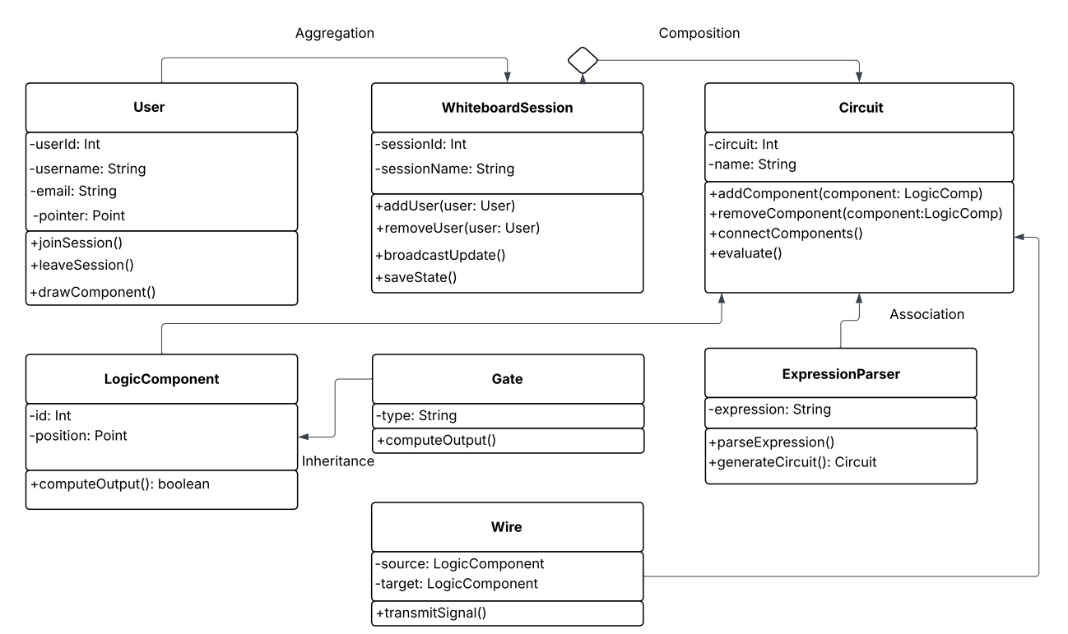
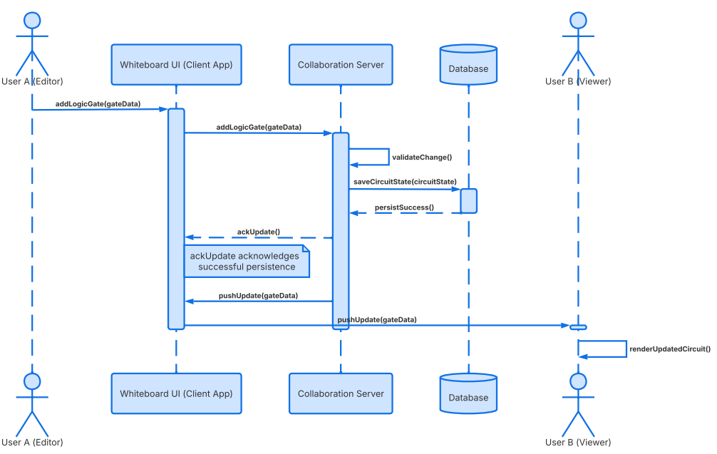
2.3. User Classes and Characteristics
The primary user class is students, who will use the system frequently during coursework and laboratory sessions. They require an intuitive interface and fast system response to efficiently design and test logic circuits. The secondary user class is instructors, who may use the system to demonstrate concepts and manage collaborative sessions. These users may require additional privileges, such as controlling or resetting shared workspaces. A third user group includes developers and testers, who interact with the system to verify functionality, performance, and correctness.
2.4. Operating Environment
The software will operate mainly on desktop web browsers like Mozilla Firefox, Microsoft Edge, Google Chrome and other chromium-based browsers. Because of that, the software will require internet connection.
2.5. Design and Implementation Constraints
The system must operate within a web browser environment, limiting implementation to web technologies such as JavaScript, HTML, and CSS. Real-time collaboration requires the use of low-latency communication protocols (e.g., WebSockets) to ensure timely synchronization between users. The system must support multiple concurrent users, which imposes performance constraints on synchronization and simulation mechanisms. Additionally, the application must maintain compatibility with major web browsers and be designed to allow future extensions without significant architectural changes.
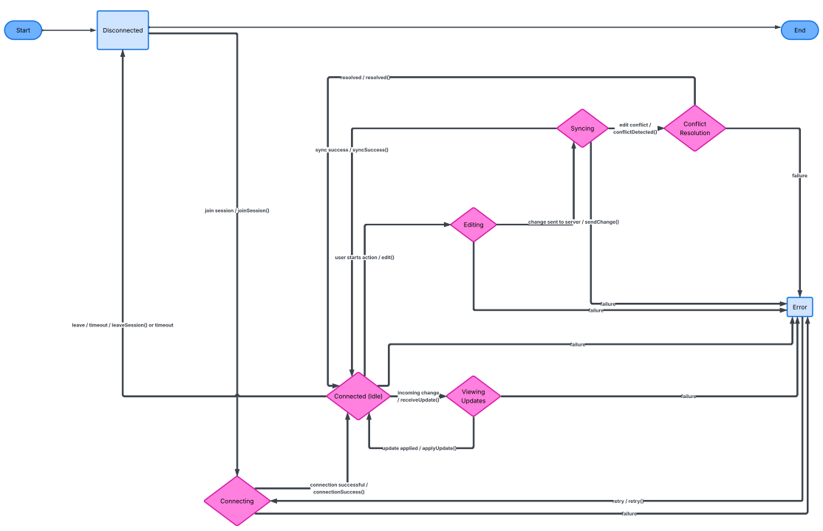
2.6. User Documentation
«List the user documentation components (such as user manuals, on-line help, and tutorials) that will be delivered along with the software. Identify any known user documentation delivery formats or standards.»
2.7. Assumptions and Dependencies
«List any assumed factors (as opposed to known facts) that could affect the requirements stated in the specification. These could include third-party or commercial components that you plan to use, issues around the development or operating environment, or constraints. The project could be affected if these assumptions are incorrect, are not shared, or change. Also identify any dependencies the project has on external factors, such as software components that you intend to reuse from another project, unless they are already documented elsewhere (for example, in the vision and scope document or the project plan).»
3. System Features
«The purpose here is to give a brief introduction to the system features, so that §4 has something to reference. Then, the full explanation of the system features is given in §5, likely referencing §4. The numbering in §3 and §5 should match.»
3.1. Real-time Collaboration
Allows multiple users to edit the same circuit simultaneously.
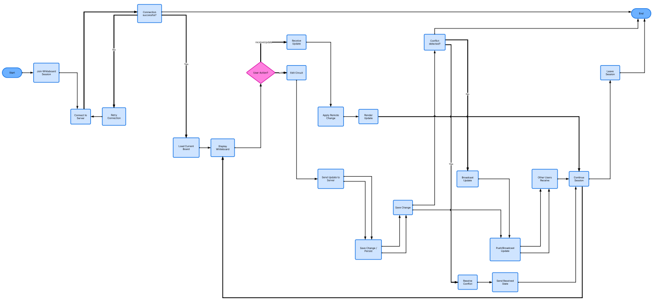
3.2. Expression Conversion
Converts Boolean expressions into logic circuits.
3.3. Circuit Simulation
Evaluates logic output dynamically.
4. External Interface Requirements
4.1. User Interfaces Overview
«Describe the high level functionality of the system from the user’s perspective. Explain how the user should be able to use your system to complete all the expected features and the feedback information that will be displayed for the user (for each screen the user will see). For example, specify whether it is GUI or text based interface and how at high level it would work. Discuss at high level how user will interact with the game such as clicking buttons, typing in some selection character, etc.»
«Describe the minimum requirements for the interface. This may include some sample screen images whether for text or GUI approach, any GUI standards or product family style guides that are to be followed, screen layout constraints, for GUI standard buttons and functions (e.g., help) that must appear on every screen, keyboard shortcuts, error message display standards, and so on»
4.2. Hardware Interfaces
«Describe the logical and physical characteristics of each interface between the software product and the hardware components of the system. This may include the supported device types, the nature of the data and control interactions between the software and the hardware, and communication protocols to be used.»
4.3. Software Interfaces
«Describe the connections between this product and other specific software components (name and version), including databases, interpreters, operating systems, tools, libraries, and integrated commercial components. Identify the data items or messages coming into the system and going out and describe the purpose of each. Describe the services needed and the nature of communications. Identify data that will be shared across software components. If the data sharing mechanism must be implemented in a specific way (for example, use of a global data area in a multitasking operating system), specify this as an implementation constraint.»
5. System Features/Modules
5.1. Real-time Collaboration
5.1.1 Description and Priority
Multi-user editing of a shared workspace. Priority: High.
5.1.2 Stimulus/Response Sequences
The user makes a change on a whiteboard
Response: The change is visible for all other students
5.1.3 Functional Requirements
FR-1.1: The system shall allow a user to create a session identified by a unique URL.
FR-1.2: The system shall allow a user to join a session using a valid URL.
FR-1.3: The system shall synchronize gate placement across users within 500 ms.
FR-1.4: The system shall synchronize wire connections across users within 500 ms.
FR-1.5: The system shall update the canvas for all users when a component is deleted within 500 ms.
5.2. Expression to Circuit Conversion
5.2.1 Description and Priority
Automatic transformation of Boolean expressions to logic circuits. Priority: Medium.
5.2.2 Stimulus/Response Sequences
The user inputs a Boolean expression
Response: The algorithm prints a logic circuit on the whiteboard on an unoccupied place.
5.2.3 Functional Requirements
FR-2.1: The system shall accept a Boolean expression as input text.
FR-2.2: The system shall generate a logic circuit from a valid Boolean expression within 4 seconds.
FR-2.3: The system shall display an error message within 1 second if the expression is invalid.
5.3. Circuit Evaluation
5.3.1 Description and Priority
Evaluate circuit options. Priority: Medium.
5.3.2 Stimulus/Response Sequences
The user selects a gate
Response: The software suggests a compatible gate.
5.3.3 Functional Requirements
FR-3.1: The system shall compute output values after any circuit change within 1 second.
FR-3.2: The system shall display output values for all output nodes.

6. Nonfunctional Requirements
6.1. Performance
NFR-1.1: The system shall support at least 10 concurrent users in a session.
NFR-1.2. The system shall process user actions within 500 ms.
6.2. Security
NFR-2.1: The system shall restrict session access to users possessing a valid session URL.
6.3 Reliability
NFR-3.1. The system shall maintain 99% uptime during operation hours.

